08.04 -
Parts Removal & Installation
Process Design & AMOS Configuration Document
Purpose
This Process Design document is provided to Key-Users to record their key decisions regarding the AMOS Process design and the required AMOS configuration.
It is updated throughout the Project Definition Phase and used as the baseline for the Final Acceptance prior to Go-Live
Revision
Author, Name | Date | Notes
BENX | 28.05.24 | First Version
DEOS | 16.12.2024 | Updated for 24.12

Table of Contents
1. Process Overview & Objectives 3
2. Regulatory References 3
3. Definitions & Glossary 3
4. Process Tasks 4
5. Process Dependencies 5
6. Process Flow 6
7. Process Design Questions 7
8. Data (Source) Mapping 8
9. Other Software Used 8
10. AMOS Configuration 9
a. Basic Data 9
b. Parameters 9
c. Workflows 11
d. Scheduled Tasks 12
e. API’s & Interfaces 12
11. Annex – Additional Info 12

Process Overview & Objectives

Process General Description:
This process contains three main flows:

- Record of installed and removed Components. (This includes removal or installation only)
- Swap between or within the same Aircraft would automatically create removal and Installation Labels.
- Component robbery is one way of material procurement in the case that no spare is available to complete / fix the maintenance event on time. The robbery process is triggered by a material request (in most cases unscheduled but scheduled also possible) which can't be served by normal way of material procurement like using stock, purchase, loan, etc.
To clear the situation and bring to aircraft as soon as possible back to flight operation a donor aircraft can be selected where the required part will be removed in serviceable condition and re-certified according to company procedures and authority regulations. The donor aircraft can be located on same station as the aircraft which have the open part request but also on different station - as soon as the location are different the part needs to be transferred / shipped according to standard processes.

Main Process Objective (Outputs & Outcomes):
- Rotable Labels:
  - Serviceable Label
  - Unserviceable Label
- Consumable Label
- Released Component in Serviceable Condition

Regulatory References

The following regulatory references were identified for this business process:
- EASA Part-145 – 145.A.50

Definitions & Glossary

Key-Words | Explanation
Label booking | Booking of a component change
Robbery | The act of removing a serviceable part from the donor aircraft to install in aircraft with open part request. "Cannibalization" is also a often used term for this.
Donor Aircraft | Aircraft were the part will be removed. Normally non-operational and under ongoing maintenace (f.e. heavy check)
APN | AMOS Program Number
TS | Identifies that the rotable was removed for Trouble Shooting.
US | Identifies that the rotable was not planned to be removed (Unscheduled).
SD | Identifies that the rotable was planned to be removed (Schedule).
A/C | Aircraft.
ACC | AMOS Competence Center.
Managed Aircraft | Aircraft for which you manage and control all maintenance.
Non-Managed A/C | Aircraft for which you perform third party maintenance.

Process Tasks

Business Process Task / Actions / Activities :
The process contains 3 main flows :
- Swap
Add the component change, select the applicable swap type :
  - Swap on same AC
  - Swap on different AC
Enter the PN1 / SN1 & PN2 / SN2. Alternatively you can select PN1 / SN1 & PN2 / SN2 from List. After adding the component change it is necessary to book the component change which normally will be performed by the maintenance.
- Removal / Installation
Add the component change by entering the label number for the installed part and enter Part – and Serial number of the removed part. It is also possible to select the removed Part- and Serial number from List (only for managed Aircraft). After adding the component change it is necessary to perform the component booking. When the booking was successful you will receive an unserviceable label for the removed part. Single bookings like :
  - Removal only & Installation only are also possible.
Note: The trigger of the EPS (Electronic Pending Shelf) depends on your strategy for further processing of the removed parts. The strategy can be setup with parameter 969 & 1176.
- Robbery
In case no parts are available and a part robbery is necessary to bring AC back to normal operation, MCC has to be select a donor aircraft where the needed part can be removed in serviceable condition.
  - MCC have to issue a Workorder in APN1418 for the donor Aircraft to remove the part in serviceable condition and handover this workorder to production.
  - Enter removed Part – and Serial Number in the component change
  - Perform removal only component booking
  - After removal & booking of the part a part request on the donor AC workorder have to be create to proceed with the material planning.
  - The removed part must be recertified & released in serviceable condition with the component inspection APN2293.

Process Dependencies

INPUT | CONCURRENT | OUTPUT
- 10.04 Part Request Fulfilment
- 00.03 Technical Assistance
- 09.01 Material Planning
- 08.20 Performing Maintenance

Process Flow
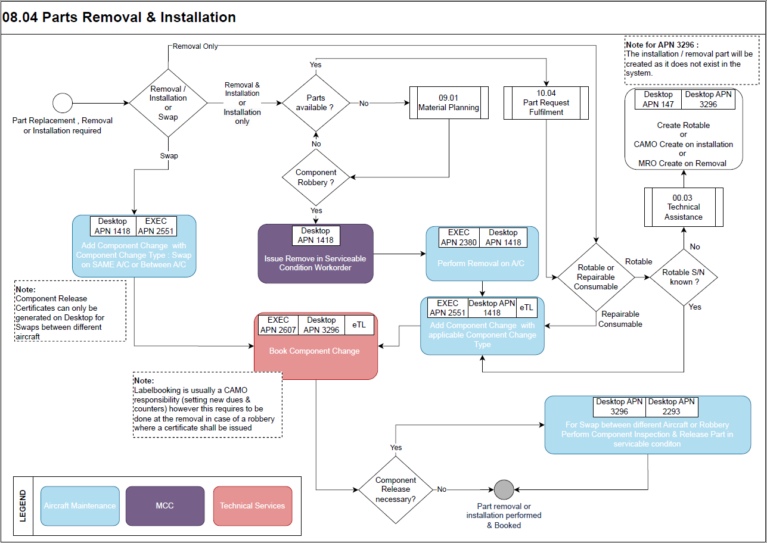

Process Design Questions

# | Question | Answer
1 | Who will perform the Label booking in AMOS?  Is it going to be one-step or 2 steps?
2 | Will you use a label in paper on which technician will write the off part?
3 | Is there a data entry team to key in ATL entry, what are their role, what do they type in?
4 | How does the mechanic confirm that installed part is Serviceable?
5 | In which cases robbery will be performed in your company?
6 | Who will trigger the robbery?
7 | Who is responsible to approve the robbery?
8 | Who will coordinate the complete robbery process and issue the scheduled workorder?
9 | Which papers / documents needs to be issued for the robbed / re-certified component according to your policy and authority?
10 | Do you rob for customers aircrafts in case of an AOG?

Data (Source) Mapping

Data Sources | Description | Volume / Manual / Automatic / Static / Dynamic
XWOPARTONOFF | Workorder-Parts Installation/Removal
XHISTORY | Component History
XHITEXT | History Transaction-Remarks

Other Software Used

Other Softwares | Used by: | Description
NIL | NIL | NIL

AMOS Configuration

Basic Data

Basic Data Table | Notes
Condition | Defines the condition of the part - selectable during receiving dialog
Position | To define the physical position of the part

Parameters

Parameter Code | Parameter Name | Notes
1255 | Use Release Certificate / Form One | Configuration of required release certificate
827 | LABEL-BOOKING: LEAVE TREE-POSITION | This parameter defines how the locations of tree parts are handled in the label-booking
1112 | LABEL LAYOUT | With this parameter it is possible to change the layout of the label independently from the current customer code.
1136 | LABEL REMOVAL-TEXT WIDTH | This parameter defines the maximum length of the "Reason for removal" field in order to fit it to the size of the corresponding field on the printed form.
1138 | CHECK PICKSLIP AT INSTALLATION | Checks in the Labelbooking if in the last X days a pickslip has been booked for the rotable to be installed. X stands for the value saved in the Amount [Integer] Field whereby 0 is to switch the parameter off.
1141 | ALWAYS SHOW REMOVAL SELECTION | With this parameter the dialog for the selection of the rotable to remove from the A/C will appear also when only one item with this partno is installed in the A/C.
1153 | LABEL:CREATE ADJUSTMENT BOOKINGS | This parameter automatically creates an adjustment booking.
1222 | LABELBOOKING POSITION FIELD | This parameter determines if the Position Field in the Label Booking is mandatory.
1394 | LABELBOOKING: TREE-CHECK AT INSTALL | This parameter determines under which conditions you want to allow a tree to be installed into an aircraft via the program "Labelbooking".
1487 | ACTIVATE LABEL SINGLE BOOKING LOGIC | Enabling this parameter will basically add a few radio buttons to mark a Label Booking as a "Special Booking".
1490 | ACTIVATE DELETION OF INSTALLATION ROTABLE ON BOOKING | Activate this parameter to remove installed rotables from AMOS.
1568 | AV. PRICE INITIALIZATION FOR EXISTING STOCK | This parameter determines how AMOS must handle existing stock for a part, which has no average price.
1603 | Validate Single Booking Compensation | This Parameter is used when Financial Consistency is ensured (Parameter 1471 is active).
1641 | LABELBOOKING LOGIC REMOVAL STORE U/S LOCATION | With this System Parameter, behavior can be steered in the AMOS modules "Rotables Label Booking" (APN 150) resp. "Component Tree Label Booking" (APN 184) regarding the filling of the input fields "Removal Store" and "Removal U/S Location".
969 | ONLY U/S TROUBLESHOOTING REMOVALS | Only U/S troubleshooting removals go to electronic pending shelf.
1176 | LABEL BOOKED REMOVAL PARTS | Label booked removal parts, strategy for further processing.
1429 | POS. FIELD REP. CONSUM. LABELBOOKING | This parameter specifies, whether the position field in the program "Consumable Repairable Labelbooking" should always be checked or never.

Workflows

Workflow Number | Workflow Name | Notes
51 | Part Removal | This workflow is triggered when a rotable component is removed during a standard label booking .
86 | Part Installation | This workflow is triggered when a rotable component is installed via the AMOS program "Rotables Label Booking".
100 | Workorder saved (post-save) | It is worthwhile to notify Engineering, especially Reliability team, that a Component Robbery has been performed
183 | Rotables Label State Before Booking | This workflow is triggered right before a "Rotables Label Booking" is executed.  It gives AMOS Customers the possibility to act depending on the state of the Label before the Booking.For example, an administrator may prohibit bookings of installation parts on aircraft with wrong A/C Type Compatibility.  Another use case may be to display AMOS customer defined warnings, in case certain part numbers mistakenly are removed with the tick box "Unscheduled Removal" selected.  NOTE: This Workflow can be used to restrict controlled position installation with non allowed partnumbers while creating action = Show Popup Dialog
231 | Verify Part Use Restrictions | This workflow is triggered during label booking & pickslip confirmation that contains part contract ID & contract IDs that match current context.
241 | Owners Swap Action | This Workflow will be triggered by the Bookings Analyzer, Component Tree Label Booking and Rotables Label Booking when an Owner Swap is performed. The error message contains all non-affected rotables.
303 | Matching Of Single Bookings | This Workflow will be triggered by the Rotables Label Booking and the Component Tree Label Booking, when a single label booking is performed.
304 | Owners Swapping on Label Bookings | This Workflow will be triggered by the Rotables Label Booking and the Component Tree Label Booking, when a single label booking is matched or a full label is performed.
404 | Depreciation Swap on Label Bookings | This Workflow will be triggered when two single label bookings are matched or a full label booking is performed. The Depreciation Swap can happen only when some special criterias are fulfilled.

Scheduled Tasks

Scheduled Task Reference | Frequency | Notes
CounterCheckService | Daily
WorkorderReportService | Daily

API’s & Interfaces

Reference | Direction | Trigger | Frequency
EXPORT MATERIAL REQUEST | Export of material request for a booked pickslip from AMOS to WinLVS.
EXPORT PART SUPPLY | Export part's price and stock information.
EXPORT PICKSLIP | Export an AMOS Pickslip.
EXPORT PICKSLIP HEADER | Export an AMOS Pickslip header. This interface is part of the paperless store solution named MDS (Mobile-Device-System).
TRANSFER PART DEFINITION | Exchange part definition data between two AMOS systems or with other systems.

Annex – Additional Info

-Nil-

